**Spring 2024: CS5720 Neural Networks & Deep Learning - ICP-3**

**Assignment-3**

**NAME:Vinay Kumar Reddy Gunuguntla**

**STUDENT ID:700745726**

Github Link:https://githu<https://github.com/VinayGunuguntla/icp3.git>b.com/VinayGunuguntla/icp3.git

Video Link: <https://drive.google.com/file/d/1322c-641LeCXm-tGJfC8eLX08PUHBFsA/view?usp=drive_link>

1. Create a class Employee and then do the following

• Create a data member to count the number of Employees

• Create a constructor to initialize name, family, salary, department

• Create a function to average salary

• Create a Fulltime Employee class and it should inherit the properties of Employee class

• Create the instances of Fulltime Employee class and Employee class and call their member functions.

**Code:**

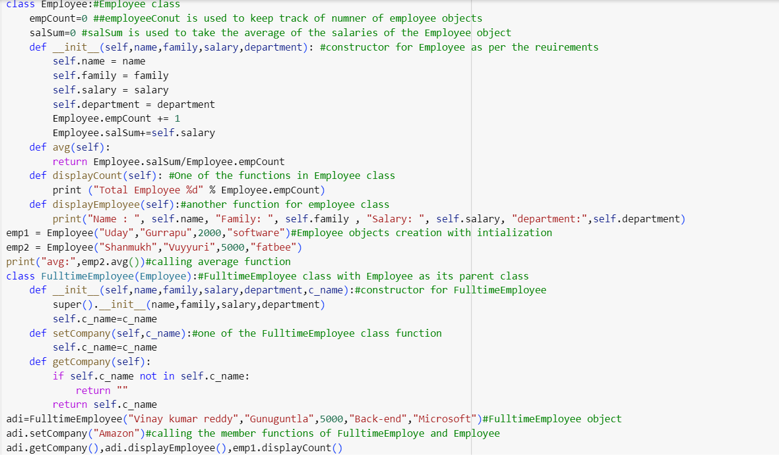

**Output:**

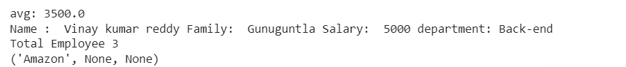

2. Numpy

Using NumPy create random vector of size 20 having only float in the range 1-20.

Then reshape the array to 4 by 5

Then replace the max in each row by 0 (axis=1)

(you can NOT implement it via for loop)

**Code:**

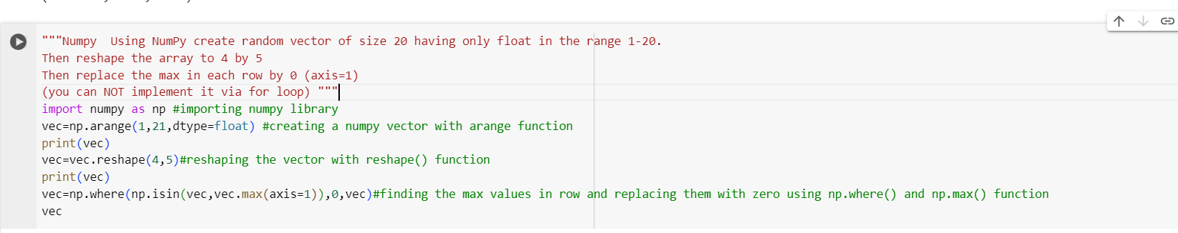

**Output:**

